**JESAH JUNIOR SCHOOL-KYABAKADDE**

**END OF TERM II EXAMINATION, 2024**

**CLASS : BABY CASS**

**SUBJECT: DRAWING & SHADING**

**My name is _____________________________________**

1. **Shade a picture of a banana.**

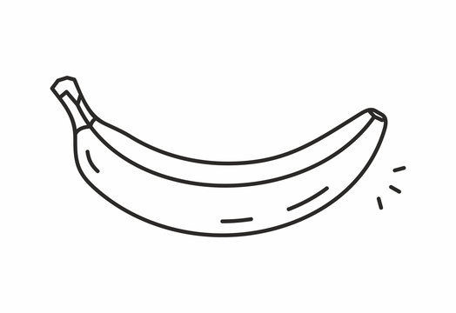

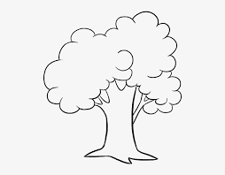2. **Draw the same pictures.**

|  |  |  |  |
| --- | --- | --- | --- |
| Sketch book open Black and White Stock Photos & Images - Alamy | 31,400+ Egg Clipart Stock Illustrations, Royalty-Free Vector ... | Cat line art png images | PNGWing |  |
|  |  |  |  |